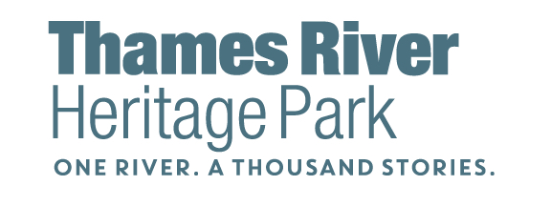

Executive Summary
November 2022

Fifty years in the making …

Proposed in 1966, established by the Connecticut legislature in 1990, and officially opened in 2016, Thames River Heritage Park is the State of Connecticut’s first and only park in the Statewide Heritage Park System.

Thames River Heritage Park Plan (Tab 3) prepared by the Yale Urban Design Workshop envisioned the Park as …

… a network of people, communities, institutions, sites, and stories connected by and to the historic waterfront and natural landscape of the Thames River and Long Island Sound;
… engaging resident and visitors in a rich program of events, culture, and experience which celebrate the diverse peoples and traditions that have shaped the life of the region;
… being designed, programmed, and promoted to make the heritage and culture vivid and accessible to all.
A key component of the plan was the establishment of an organizational structure to support the Park and move the plan forward. Towards this end Thames River Heritage Park Foundation was established and an executive director was retained. Since its inception, the Foundation has been moving the plan forward, implementing the majority of the Phase I and II recommendations.
Accomplishments to date include:
- Established a dynamic board of directors comprised of local and state officials, community and business leaders, and partner representatives.

- Established partner / stakeholder organization with over 20 sites and institutional partners which meet quarterly to discuss opportunities, coordinate branding and promotion and collaborative program development.

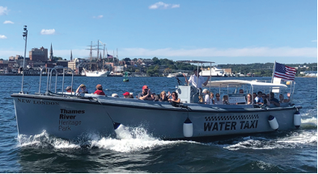
- Established a water shuttle system comprised of 2 former navy utility boats connecting downtown New London, Fort Trumbull and Fort Griswold along the plans to open a new dock at the Submarine Force Library and Museum and the refurbishment of a 3rd boat to connect SFLM to the shuttle system. Ridership was at 11,000 in 2019, 4,000 in 2020, 7,000 in 2021 and 10,000+ in 2022.

- Developed brand and communications design, initiated directional signage for highways exits and roadways, and developed and distributed branding guidelines.

- Created and distributed The Interpreter’s Guide to Thames River Heritage Park, a guidebook for interpreters, volunteers, and partner sites. - Tab 7
- Hosted over 140 boat tours on the rich history of the heritage sites on the Thames along with full moon and other themed cruises in collaboration with historic site partners and municipal event organizers during the 2021 and 2022 seasons and water shuttle service for partner site tours of Ledge Lighthouse at the mouth of the Thames River.
SUBMARINES, BATTLEFIELDS and BETRAYERS
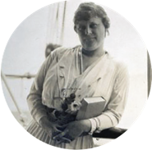
Military Stories on the Thames

WELL-HEELED AND WANNABEES
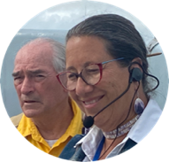
Gilded Age on the Thames

WATER, WAMPUM and MEDICINE WHEELS
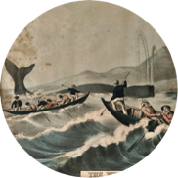
Mohegan Life on the Thames

BLOWHOLES, BLUBBER and BREACHES
Whaling Tales on the Thames

- Created quests - self-guided, family-friendly treasure-seeking hikes - that take participants to Fort Trumbull State Park, Waterfront Park in Downtown New London, Fort Griswold Battlefield State Park and Thames Street in Groton and invite them to follow a series of clues to learn about the history and ecology of the area while solving a word puzzle. The quests are the Park’s registered program for Connecticut Trails Day.
- Developed 5 self-guided, audio tours located on the free izi.TRAVEL app (https://www.izi.travel/en), a multi-media platform that allows people to use their mobile device to download museum content and travel easily while participating in regional storytelling.
In 2022 TRHP Foundation also …

… Designed and implemented a highly acclaimed Docent Academy graduating 25 in the 2022 inaugural class. Overall, the participants knowledge, interest, understanding, and commitment to Park increased an average of 127% - more than double. The overall program rating was 4.89 out of 5.

… Established a monthly winter lecture series, Past and Present Visions of the Thames, held at Fort Trumbull State Park Conference Center.

… Implemented a collaborative, integrated marketing campaign - Discover the Thames, complete with billboards, brochures, social media and print ads, and eblasts to promote the Park sites and events funded with grant from DECD’s Eastern Regional Tourism District and partner in the Park.

… Increased private grant funding to support collaborative programs like the Docent Academy, summer youth programs, and the refurbishment of the 3rd boat – the Nameaug.

… Added 6 new partner sites (Cedar Grove Cemetery, New London Custom House, New London Black Heritage Trail, Old Town Mill, Pequot Chapel, and Ye Antientist Burial Ground) and 2 new institutional partners (OpSail Connecticut/Connecticut Maritime Heritage Festival and New London Maritime Society).

The Foundation’s three-year strategic plan, is focused on 4 primary goals:

- To increase partner site visitation by 15% (5% each year)

- To increase fiscal stability by shifting revenue from
65% government funding / 35% nongovernment grants and donations to
50% government funding / 50% nongovernment grants and donations

- To maintain high functioning, consistent facilities and staff

- To build a diverse, engaged board of directors with 100% financial and committee participation

A collaborative partnership between the State of Connecticut’s DOT, DEEP, and DECD and the Foundation is critical to the Foundation’s capacity to continue to effectively implement the recommendations of the Yale Urban Design Workshop and the Foundation’s three-year strategic plan in fulfillment of its mission to connect, support, promote and sustain Thames River Heritage Park.

DOT active partnership and commitment might include, but is not limited to:

- Line-item funding of $210,000 to support $50K per boat for annual maintenance and operation and $60K for winter boat storage ($20K/boat) for FYE 2024 and 2025.
- Advocate for State funding for water shuttle and historic boat tour operation.
- Advocate for boat winter storage at Fort Trumbull State Park.

DEEP active partnership and commitment might include, but is not limited to:

- Addition of Thames River Heritage Park to the listing of state parks, historic parks and museums, field trip sites, Park ConneCT, Find Park by Activities (boat tours, harbor cruises), etc.
- Winter boat storage at Fort Trumbull State Park
- Use of the parks and park infrastructure: docks, office, storage, meeting facilities
- DEEP liaison / representative to the Foundation
- Staff support to help develop TRHP programming for “No Child Left Inside” and “Sky’s the Limit”, to collaborate on adding THRP to DEEP’s Heritage Passport program, and other collaborations as mutually agreed.
- Support with grant applications sought by the Foundation – letters of support, research, etc.
- Lead grant applications available only to state agencies
- Guide and assist with additional highway signage to promote Park
- Advocate for State funding for water shuttle operation (DOT) and the Park

DECD active partnership and commitment might include, but is not limited to:
- Promotion and increased presence of Thames River Heritage Park and recognition on State’s tourism website, CTVisit.com
- Promotion of Thames River Heritage Park by CT Office of the Arts
- Promotion of Thames River Heritage Park by local Designated Regional Service Organization
- Increased presence in CT marketing campaigns
- Increased funding for marketing

With the knowledge and consent of DEEP, DOT and DECD, the Foundation’s active partnership and commitment would continue, but is not limited to:
- Administration of the contract for the water shuttle operation
- Procurement of public/private funding for the operations and marketing of the Park
- Creation of partnerships with cultural institutions, private businesses, educational institutions, military institutions and municipalities
- Development of the Park experience including membership, program development, theme and stories
- Development of the Nautilus dock and water shuttle to / from the Nautilus dock to City Pier to connect with the shuttle to Fort Trumbull and Groton Landing.
- Recruitment, selection and management of the staff to support the Foundation’s activities

