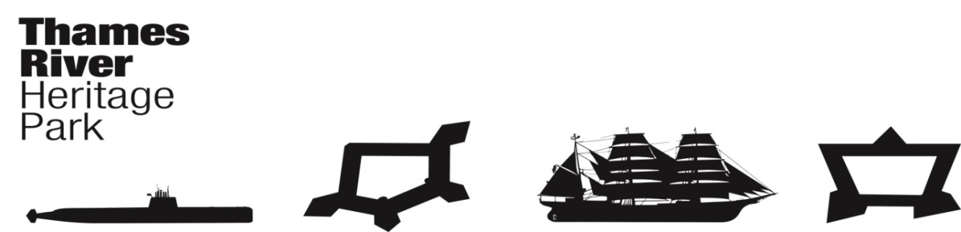
Thames River Heritage Park
Transition Team Meeting
Wednesday, February 24, 2016, 8:30AM (0830)
Council Chambers, City of Groton Municipal Building
295 Meridian St., Groton
Groton, Connecticut
Minutes

Attendance: Penny Parsekian (Acting Chair), Pamela Aey Adams (Secretary), Brent Eugenides, Deborah Donovan, Marian Galbraith, Paige R. Bronk, Ellen Cummings

I. Call to Order: P. Parsekian
Meeting called to order at 8:32AM

II. THRP Chairman’s Report/Announcements
Chris Cox has been negotiating with two Sponsors for the Thames River Heritage Park event at the Garde Arts Theater on March 31, 2016. Sponsors have tentatively agreed to cover the cost of the event which would include printing of the maps and guide to be handed out at the event. Names of sponsors cannot be released until negotiations are complete.

III. Approval of Minutes January27, 2016 – P. Adams
MM: P. Parsekian - Approve Minutes as presented
MS: P. Bronk
Vote: All in favor

IV. Fiduciary Report – J. Butler - Presented by M. Galbraith
Expenditures to date = $14,564.40 (Includes: De-preservation, transportation, marine survey & safety inspection, Notices to New London Landmarks and the New London Day, Printing of Yale Study and Appendix. Remaining funds = $30, 935.60

V. Committee Reports
A. Organization Committee – Chair: Juliet Hodge
No Report available for this meeting

B. Governance Committee – Chair: Joe Selinger – Presented by P. Parsekian
1. Certificate of Incorporation Filing – Complete
2. Finalize By-Laws – Please review so that a final vote can be done next month

C. Finance Committee – Chair: Brent Eugenides
Draft Operating & Capital Budgets and a Draft Fundraising Plan was presented (See Attached)
Brent emphasized the fact that this is a VERY Preliminary Draft.

The plan counts on an annual continuing contribution of $10,000/municipality. This was a surprise to Committee and to Mayor Galbraith from the City of Groton who was present. Municipalities are well into the Budget process and this contribution is not on anyone’s radar. Chairman Cox will need to get a letter out to the Town and City of Groton and the City of New London ASAP. Given the current state of the State Budget and the potential for budget reductions to municipalities this may be a difficult ask.
The Committee proposed asking for grants, donations from foundations and sponsorships as possibilities for revenue generation.
The Committee also does not have a lot of information on the possible expenses – will know more after RFP is reviewed and an Operator selected.

M. Galbraith mentioned that the February Bond Commission Meeting was cancelled. The next meeting is scheduled for March. Hence, no information on the $755,000 grant

D. Communications & Programming Committee – Chair: Penny Parsekian
The report from the Communications & Program Committee was sent out for the TT to read.

P.O. Box & Address. P. Parsekian discussed the need for a P.O. Box and an Address for Google Maps. The Communications Committee will ask Barbara Neff if the “Rocket Ship” at the Pier could be used for mail. Adding a mail slot would be difficult but, attaching a box with a slot to the exterior of the building might be doable. According to Deborah Donovan, a P.O. Box is $66/year.
The Committee feels a mail drop at the Rocket Ship is a good idea. Further exploration as to the feasibility is needed.

TRHP March 31 event – All members of the Transition Teams are expected to attend.

Brief discussion was held on what are the plans for the TRHP if the State money does not come through. The $100,000/year for 2 years is certain – Other funding is not certain. The TRHP may have to operate as a volunteer group for a while. Getting the boats operational is critical to the success of the TRHP. A social media campaign will have to be developed and, someone will have to stay on top of the Social media (postings, responses, etc.)

Report from Penny Newbury was discussed. She sent the following Statistics and additional information which is attached:

Twitter:
Followers: 32
Following: 125
Tweets: 70

Facebook:
Total likes: 222 (up by 17%)
59% are women
39% are men
Ages: see graph (attached)
Location: see graph (attached)
Last 5 posts: see graph (attached)

Website for the period 1/23/16-2/22/16:
Sessions: 337
Users:236
Pageviews: 1596
Pages/session: 4.74
Ave Session Duration: 01:49
Bounce rate: 6.82%

Deb Donovan reminded everyone to share TRHP FB page with you friends.
Marian suggested putting a hashtag (#) in the post as well.
It was suggested that detailed directions should be provided to all of the TRHP sites and supporters as to how to Share on Facebook/Twitter

E. Water Taxi Planning and Operations – Chair: Marian Galbraith
Committee met Feb 9, 2016

- Reviewed the Marine Survey Report. Cost to put boats in operating condition is $44,000 ($20,000 and $24,000)
- Submitted Application to USCG for Certification to Carry Passengers
- Registration – Municipalities do not have to carry a registration form the state – just need the city/town name on the bow.
- City name on the bow but, the name on the stern can be shorter. Marian suggested “City of Groton” and “City of New London” for names. Paige Bronk suggested that for safety and radio transmission purposes the names be shortened to “Groton” and “New London.” Other name suggestions were “Griswold” and “Trumbull.” Some members of the Water Taxi Committee did not like these names as there are additional sites which would not be reflected in the name. Deb pointed out the names come from the Governors – not the sites.
- Continuing work on the MOU with the DEEP
- Also working on a contract with the City of New London for use of City Pier
- Met with the New London Port Authority to secure moorings for the vessels.
- DOT permits are needed. DOT would return the $100,000 but wants a % of the ticket $$. J. Butler is working on this.
- The TT pointed out that the TRHP Water Taxi will not be a money maker at least for the first three years.
- Water Taxi Committee is discussing Partnerships. The New London Ledge Light Group has approached Water Taxi Comm. About bringing passengers out to the lighthouse and also bringing materials out when boats are not being used for passenger/tour service.
- Tall ships (The Pride of Baltimore and the USCG Eagle) will be visiting May 2-6, 2016. A request has been made to use the boats for tours if they are ready.
- RFP’s for operators have been read through. Interviews are being set up. The Water Taxi Committee hopes to make a recommendation to the TT at the March meeting.

VI. Good of the Order

Deb Donovan described a good marketing program used by sites in Seattle, Washington. Site photographers take free photos of visitors. Photos are entered into a kiosk and then send to social media (Chihuly Museum is an example) then out to your friends. Provides great information on the site and, gets email information for future advertising.

The April 27, 2016 TT meeting date conflicts with the Governor’s Tourism Conference. The TT moved the meeting date to May 4. The May 24, 2016 meeting will also be held.

VII. Next Meeting Date: March 23, 2016 @ 0830

VIII. Next Meeting Location - Fort Trumbull Conference Center

IX. Adjourn 9:17
MM: P. Adams
MS: D. Donovan
Vote: All in favor

Respectfully submitted,
Pamela Aey Adams
Secretary

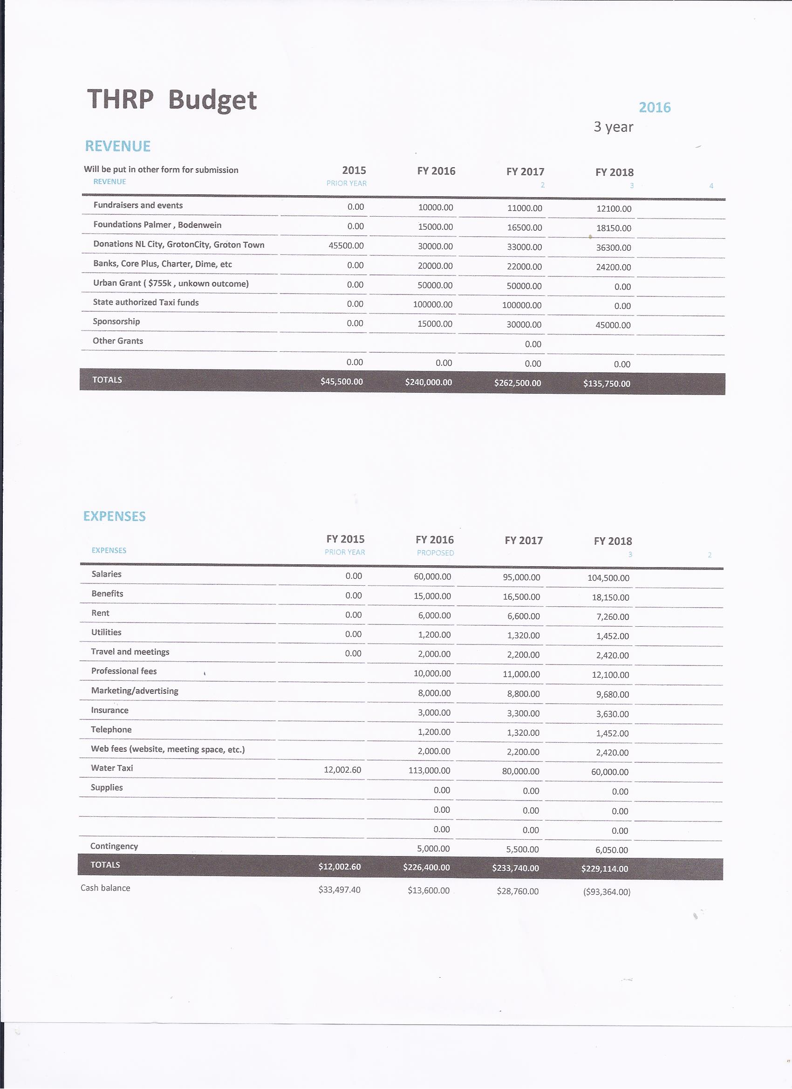

Social media
