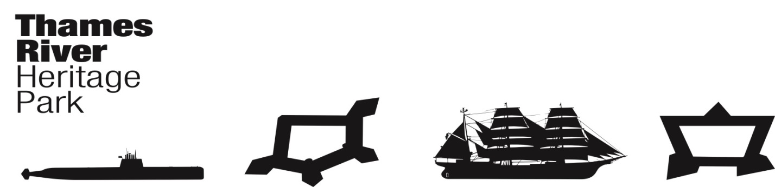
Thames River Heritage Park
Transition Team Meeting - Minutes
Wednesday, October 28, 2015, 0915
Mohegan Sun Convention Center/Uncas Ballroom
Uncasville, Connecticut

Attendance: C. Cox (Chair), P. Parsekian, D. Donovan, K. Clarke, J. Hodge, M. Galbraith, B. Eugenides, R. Ross, R. Grahn, P. Adams (Secretary)

While Agenda items were taken out of order, the minutes will follow the Agenda for consistency.

I. Call to Order: 0915 (M. Galbraith)

II. THRP Chairman’s Report/Announcements
B. Eugenides has volunteered to Chair the Finance Committee

III. Approval of Minutes September 23, 2015 – P. Adams
MM: J. Hodge – Approve Minutes as presented.
MS: R. Grahn
Vote: 9 in favor and 1 abstention

IV. Fiduciary Report
None

V. Committee Reports
A. Organization Committee – Chair: Juliet Hodge

- The TRHP Timeline for task completion was presented. The Committee felt that we are still on track to complete all tasks in the timeframe presented.

- Office space for the new Not for Profit organization was discussed.
There is some space available on the upper floor of the SECTER Building but, it is not ADA Compliant.
The New London Train Station has some space available but, there may be some structural issues which would preclude use of the space for the next 18 months.
Fort Trumbull SP – At an upcoming meeting between the TRHP and DEEP, a request will be made to have temporary office space within the building.
- Office space will not be needed until the Executive Director is hired.

B. Governance Committee – Chair: Joe Selinger
1. Name of Organization

MM: C. Cox – The new Not-for-profit organization will be called the
“Thames River Heritage Park Foundation”
MS: D. Donovan
Vote: All in favor

2. Mission Statement

Since it is time-critical to have a Mission Statement in place for application purposes, the draft Mission Statement sent to Committee members and dated October 13, 2015 (See below) should be voted on at today’s meeting. Committee members will look at comments submitted by TT members and tweak the statement at a future date.

MM: P. Parsekian – To approve Mission Statement 10-13-15
MS: B. Eugenedes
Vote: All in favor
“The Thames River Heritage Park Foundation is a nonprofit organization whose mission and purpose is to develop, promote, coordinate, and help preserve a new type of Connecticut state park known as the Thames River Heritage Park, which will include sites of national and historical significance along the Thames River in and around the City and Town of Groton and New London, located across from each other near the mouth of the river. The Foundation carries out its purpose in collaboration with the State of Connecticut, the United States Coast Guard, the United States Navy, local municipalities and regional authorities, and the numerous heritage sites within its area. A primary role of the Foundation is the oversight and operation of a water shuttle system designed to transport visitors to and from sites of significance on both sides of the Thames River.”

C. Finance Committee – Chair: Chris Cox
B. Eugenides has volunteered to Chair the Finance Committee
MM: M. Galbraith – To approve B. Eugenides as the Chair of the TRHP TT Finance Committee.
MS: K. Clarke
Vote: All in favor

D. Communications & Programming Committee – Chair: Penny Parsekian

- Yale Report and Appendix is available for purchase online at $35 and $11 respectively. P. Parsekian will send out link to committee members. Strongly advise that Committee members have these materials.

- OP-ED piece in the Sunday October 25th edition of the New London Day is outstanding. Richard Grahn did an excellent job in his presentation.

- Urban Action Grant - Efforts will be made to put the request for the $755,000 UAG on the Bond Commission Agenda for January. Bob Ross will speak with Peter Lent about moving the request forward to the Bond Commission. Grant request includes Signage Plans, Phase I of the signage and installation, some transportation infrastructure and $50,000/year for two years as start-up funding for the Thames River Heritage Park Foundation.

- Marketing Plan is not yet ready for presentation. C. Cox is shifting this plan to more of a Marketing/Branding Plan. D. Donovan did an excellent job of preparing the initial plan.
- New London Rotary Grant not approved for TRHP
- Website/Social Media – Emily Ross Feltes will hold off on the trailer for the website until the branding plan is more developed.
- November 12 – C. Cox scheduled a meeting with the DEEP to make certain the state’s historic sites are united in the park effort. Also will discuss State’s involvement with the ACOE permitting process for the Nautilus Water Taxi Dock.
- C. Cox will be discussing a TRHP book (similar to the Charles W. Morgan book) with the New London Day.

E. Water Taxi Planning and Operations – Chair: Marian Galbraith

- The TT Water Taxi Committee applied for the two surplus Navy vessels immediately upon learning the no first-in-line federal agencies requested these boats. A decision is expected by November 9, 2015. Additional “Letters of Need” may be submitted to J. Carlos Velez – P. Adams to forward email from M. Galbraith with the appropriate address included (Done 10-28-15)
- Cost to deliver two boats to Connecticut will be ~$7000
- Mark Jalbert will speak with Dave Crocker this Friday regarding Storage Space and, if it would be permissible for a 3rd Party to come in and do maintenance/repair work. P. Parsekian will attend this meeting with Mark.
- The funding from the State of Connecticut will likely be paid in the form of reimbursement. COG may be able to help with a bridge payment to be reimbursed by the TRHP TT. The TT should make request to COG.
- Cross Sound Ferry funding is still in place.
- Bob Ross brought along the original plans for the Water Taxi Dock at the Nautilus Pier. Plans will be submitted to DEEP for any updates. Need to know who will be responsible for permitting and construction of the Water Taxi Dock. The Navy will not own or maintain the Water Taxi Dock. Bob offered to shepherd this process.

VI. Good of the Order

C. Cox outlined his top priorities for the TRHP TT. They are as follows:

- Current Business
- Procure Boats
- State Urban Action Grant Money

- Business Plan ~ Fundraising Plan
- Board Development/501C3

- Communications
- Connect with DEEP /State Parks – Tom Tyler et al.
- Relationship management
- Brand, media, audience: marketing plan

- Media Projects in anticipation of Spring 2016 Water Taxi
- Signage and Wayfinding

- Editorial – CT Explored & New London Day
- Freedom Trail Relationship
- Tourism – District & State

- High Potential Program Development Activities
- LEARN, Inc. – demonstration projects: cultural journalism in schools/with teachers/with student participation

- Collaboration with Community Foundation

- New London Day – book and web-based content

- Area Collecting organizations – Maps & Images
- Lyman Allyn Museum – potential exhibition
- Avery Copp House – How we tell our stories

- Arts & Culture Partnership – Eastern Symphony Orchestra & Garde Arts Theater.

Bob Ross has monthly meetings with local school Superintendents with the next meeting being tomorrow. Chris Cox is welcome to attend with Bob Ross.

Kristin Clarke - Steering Committee – Discussed capacity building especially getting smaller historic sites involved. Stories and continuity.

VII. Next Meeting Date & Location
The November and December meetings have been combined with the new between- holiday meeting set for Wednesday, December 09, 2015 0830 at either the Submarine Force Museum or, Fort Trumbull State Park. Secretary Adams will advise membership of location.

IX. Adjourn @ 0958

Respectfully submitted,
Pamela Aey Adams
Secretary

