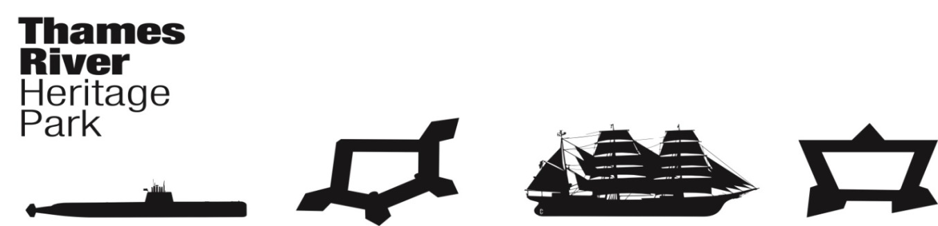
Thames River Heritage Park
Transition Team Meeting - Agenda
Wednesday, May 25, 2016, 8:30AM (0830)
Fort Trumbull State Park Conference Center
90 Walbach Street
New London, Connecticut

I. Call to Order: C. Cox

II. THRP Chairman’s Report/Announcements
Consideration, discussion regarding Foundation Board Members
Possible vote on proposed members.
Report on meeting with Seabird Enterprises regarding van transportation to Nautilus

III. Approval of Minutes –P. Adams
April 18, 2016 Special Meeting - revised
May 4, 2016

IV. Fiduciary Report – J. Butler
Charter Membership - status

V. Committee Reports
A. Organization Committee – Chair: Juliet Hodge
1. Identify purpose/intent of the office
2. Budget
3. Location
4. Timeline Revision?

B. Governance Committee – Chair: Joe Selinger
Bylaws & Foundation status

C. Finance Committee – Chair: Brent Eugenides
1. Operating & Capital Budgets - refined
2. Fundraising Plan

D. Communications & Programming Committee – Chair: Penny Parsekian
1. Grand Opening for Water Taxi - Planning
2. Community Building with Heritage Sites to Improve Visitor Experience
3. Heritage Park and Water Taxi Marketing Plan
4. Funding Needs and Funds Raised
5. Other

E. Water Taxi Planning and Operations – Chair: Marian Galbraith
1. MOU – DEEP
2. MOU – CONNDOT
3. US Coast Guard – COI
4. Nautilus Water Taxi Dock – on hold for the immediate future. Pans need to be revised and all permits must be obtained. Due to severe budget issues, there is no funding to proceed.
5. Report on presentation to Eastern CT Chamber of Commerce.

VI. Good of the Order

VII. Next Meeting Date(s) & Location

June 22, 2016 @ 0830 (Submarine Force Museum – Nautilus)
July 27, 2016 @0830 (Fort Trumbull)

VIII. Adjourn

PO Box & Social Media Addresses:

Thames River Heritage Park
1 Waterfront Park
PO Box 851
New London, 06320

Twitter account: twitter.com/thamesriverpark
Website: www.thamesriverheritagepark.org
Email: info@thamesriverheritagepark.org
Facebook: facebook.com/thamesriverheritagepark

