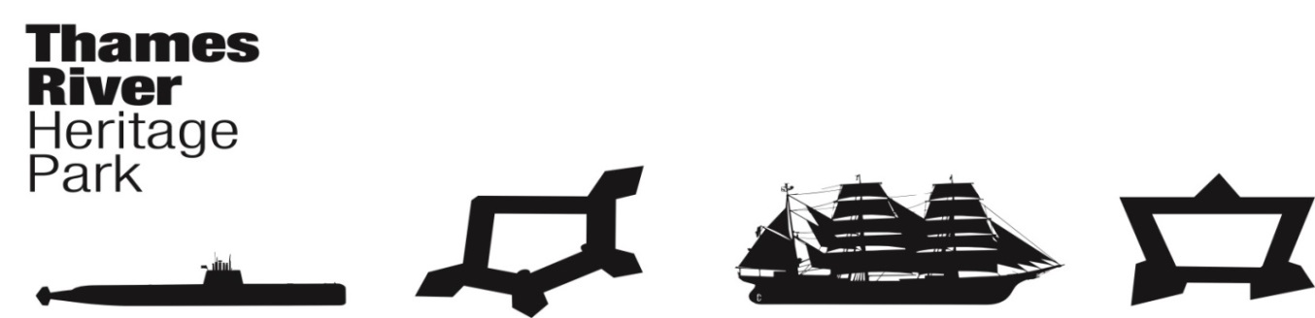
Thames River Heritage Park
Transition Team Meeting - Agenda
Wednesday, March 23, 2016, 8:30AM (0830)
Ft Trumbull Conference Center
90 Walback Street
New London, Connecticut

I. Call to Order: C. Cox

II. THRP Chairman’s Report/Announcements
Parade

III. Approval of Minutes February 24, 2016 – P. Adams

IV. Fiduciary Report – J. Butler

V. Committee Reports
A. Organization Committee – Chair: Juliet Hodge
1. Identify purpose/intent of the office
2. Budget
3. Location
4. Timeline Revision?

B. Governance Committee – Chair: Joe Selinger
1. Finalize By-Laws

C. Finance Committee – Chair: Brent Eugenides
1. Operating & Capital Budgets
2. Fundraising Plan

D. Communications & Programming Committee – Chair: Penny Parsekian
1. TRHP Event @ Garde Arts
2. PO Box
3. Water Taxi Marketing
4. Website Hosting

E. Water Taxi Planning and Operations – Chair: Marian Galbraith
1. RFP – Review Committee
2. MOU – DEEP
3. MOU – CONNDOT
4. US Coast Guard - COI

VI. Good of the Order

VII. Next Meeting Date(s)

April 27, 2016 @ 0830 May 25, 2016 @ 0830 June 22, 2016 @ 0830
July 27, 2016 @0830

VIII. Next Meeting Location

IX. Adjourn

