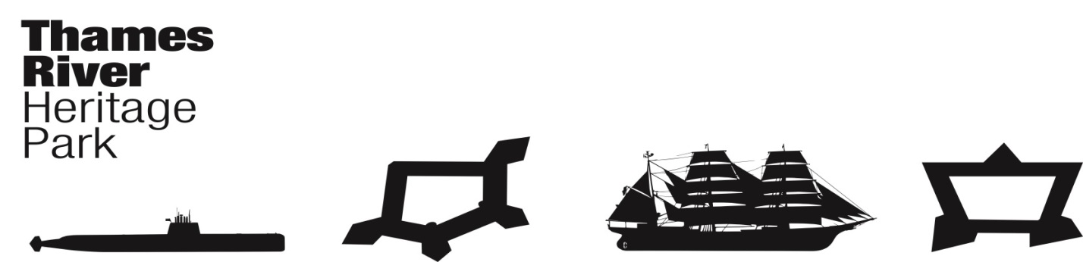
Thames River Heritage Park
Transition Team Meeting - Agenda
Wednesday, January 27, 2016, 8:30AM (0830)
Ft Trumbull State Park Conference Center
Groton, Connecticut

I. Call to Order: C. Cox

II. THRP Chairman’s Report/Announcements

III. Approval of Minutes December 9, 2015 – P. Adams

IV. Fiduciary Report – J. Butler

V. Committee Reports
A. Organization Committee – Chair: Juliet Hodge
1. Scope of Work
2. Office Space

B. Governance Committee – Chair: Joe Selinger
1. Adopt Yale Report as the TRHP Strategic Plan
2. Review draft Certificate of Incorporation
3. Review draft By-Laws

C. Finance Committee – Chair: Brent Eugenides
1. Operating & Capital Budgets
2. Spending Guidelines
a) Purchase additional copies of Yale report for sponsorship development ($34 + shipping)
b) Purchase additional copies of Appendix
($11)
c) Other expenses
3. Fundraising Plan

D. Communications & Programming Committee – Chair: Penny Parsekian

E. Water Taxi Planning and Operations – Chair: Marian Galbraith
1. RFP – Review Committee

VI. Good of the Order

VII. Next Meeting Date(s)

February 24, 2016 @ 0830 April 27, 2016 @ 0830 June 22, 2016 @ 0830
March 23, 2016 @ 0830 May 25, 2016 @ 0830 July 27, 2016 @0830

VIII. Next Meeting Location

IX. Adjourn

